**The Different Features between**

**Villa Savoye and the Fallingwater**

Firstly, The Villa Savoye is considered by many to be the seminal work of the Swiss architect Le Corbusier. This unique building is located at Poissy which is located outside of Paris. Also, this building is an iconic architectural example of early modernism which is also known as the International Style of architecture. The Villa Savoye was completed in 1929 but fell into disrepair during the World War II. But luckily, it has been fully restored and is open for viewing for visitors. Le Corbusier applied a few principles which is known as “The Five Points of Architecture" into his basic tenets of a new aesthetic of architecture which are the pilotis, a flat roof terrace, the free plan, horizontal windows and the freely-designed façade.

Moving into the Fallingwater, it is designed by an American architect named Frank Lloyd Wright, which is also the founding father of modernism architecture. The fallingwater was built for Edgar Kaufmann in southwestern Pennsylvania. It sits over a waterfall using an architectural device known as the cantilever. Mr. Wright described his architectural style as ‘organic" and then applied the concept of organic architecture into the building. The concept of the house are in harmony with nature, and though Fallingwater reveals vocabulary drawn from the International style in certain aspects, this country house exhibits so many features typical of Frank's natural style, the house produce a very good relationship with its surroundings.

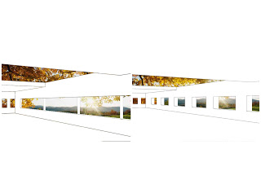 Back to Villa Savoye, the outside of the building is covered with a smooth material which is known as the white stucco. One of the most unique features of the Villa Savoye is the ribbon of glass that wraps completely around all four sides of the second level of the building. The main reason for the ribbon of glass is to provide abundant natural lighting to the interior of the building.

Figure 1.0 shows the ribbon windows with the view of the outdoor landscape

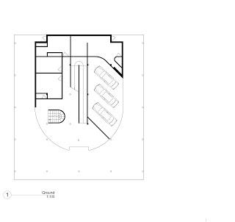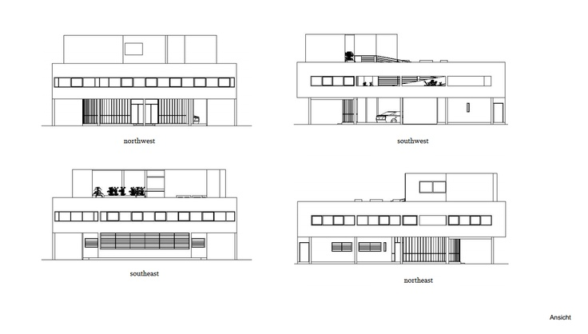 Another interesting fact about the Villa Savoye is that it is unusual in that it is hard to tell where the front elevation of the house is. This is the main idea of Le Corbusier when he first designed the house. Furthermore, the house was intended to have a garage for car parks. Therefore, parking garage is located under the house and is the central feature of the ground floor plan. The Villa Savoye look like it is floating because it is elevated on white pilotis which is also known as the slender columns.

Figure 1.1 shows all four elevations of the Villa Savoye

Figure 1.2 shows the ground floor plan

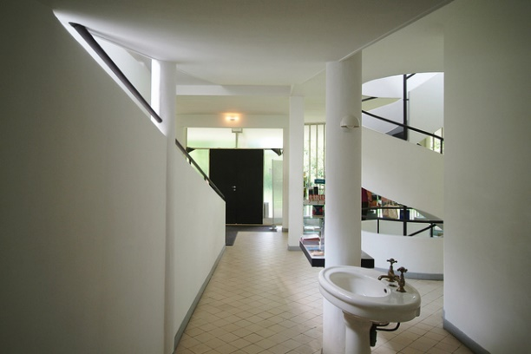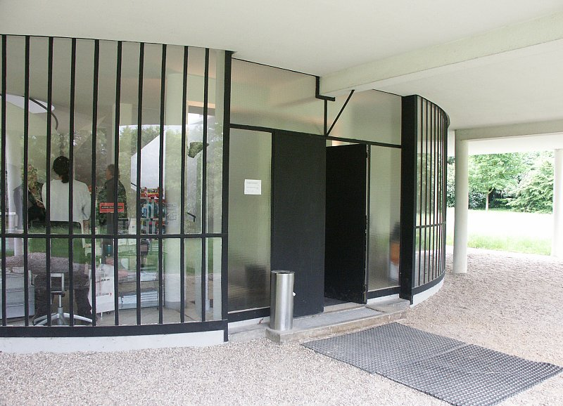 Next, the ground level is fortunate enough to have three car garage, a quarters for servants, chauffeur’s apartment, and a big entrance hall. The entrance hall is painted white to match the exterior and the interior of the house. Most of the structure in the house is painted white in colour. For example, the walls and ceiling are white in colour because the materials being used is the white stucco and also the tile on the floor is also white. The hall receives abundant natural light through a glass wall, and also has an indirect artificial lighting from electric lights aimed at the white ceiling. In the hall, a row of a few columns of different form, one of which is designed to act as a small table. Furthermore, right at the back of this column that act as a small table, stands a small sink. From the entrance hall at the ground floor, a ramp and a spiral staircase is present to allow easy access to the second story of the building which meet on the second floor landing which natural light is also present.

Figure 1.4 shows the entrance view from the inside of the Villa Savoye

Figure 1.3 shows the entrance of the Villa Savoye

  Moving towards the second floor of the building, it contains the pantry, kitchen, living room, and bedrooms and last but not least, a beautiful exposed garden terrace. The pantry, kitchen, and living room are designed to be in line towards the northwest side of the house, whereas the bedrooms are a little bit different because it lies along the northeast and southeast sides. Not to forget the beautiful outdoor garden, it lies on the southwest side. The Villa Savoye has a great amount of storage space which includes shelving departments, variety of cupboards and compartments built into the walls in respective rooms. Another important feature in the house is that a central heating system is provided with the heat emanating from radiators, which are apparently water filled to save electricity.

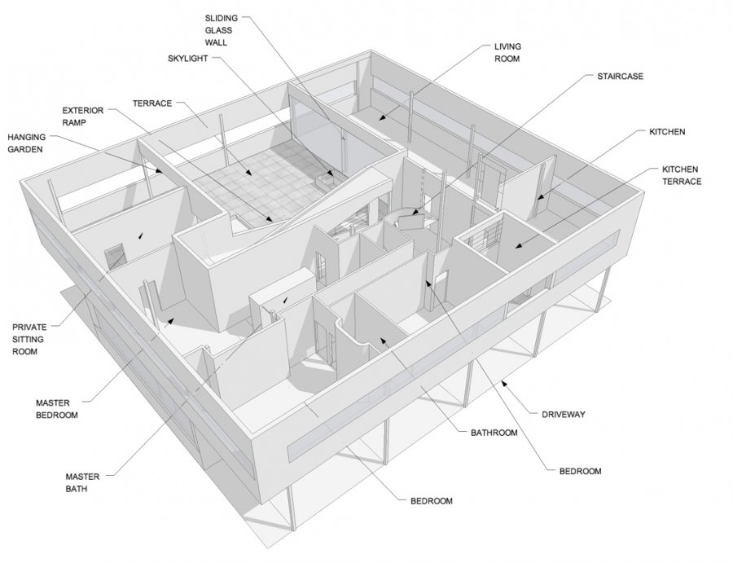

Figure 1.5 shows the bird view of the second floor from the top of the Villa Savoye

The pantry and the kitchen placed at the corner of the northwest and northeast sides because natural light is easily entered by the windows that covers the two sides. In addition, there are built-in cupboards with sliding doors under these. Based on the plan of the kitchen, it is more or less the shape of a square. Furthermore, the floor of the kitchen is covered in pale yellow tile. Also, the counters blend in with the pale yellow tile because it is white in colour. The kitchen is equipped with a refrigerator, double sink, electric oven, stoves and a grill. However, the living room is different because it is rectangular in shape and very large in size, approximately 20ft wide and 50ft long. Also, at one end it contains a dining area near the pantry. The landing is placed in the hall where the living room can be easily, or the pantry, as well as from the beautiful garden terrace, from which it is separated by a wall of sliding glass panels. In addition, right below the strip window are built in cupboards with sliding doors. The colour of the walls 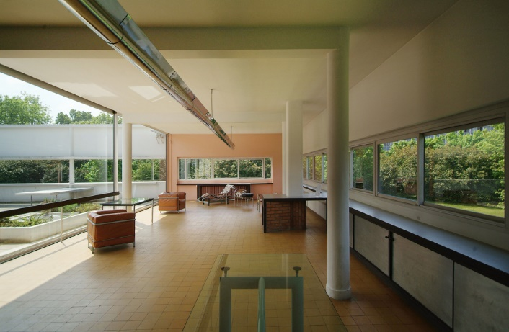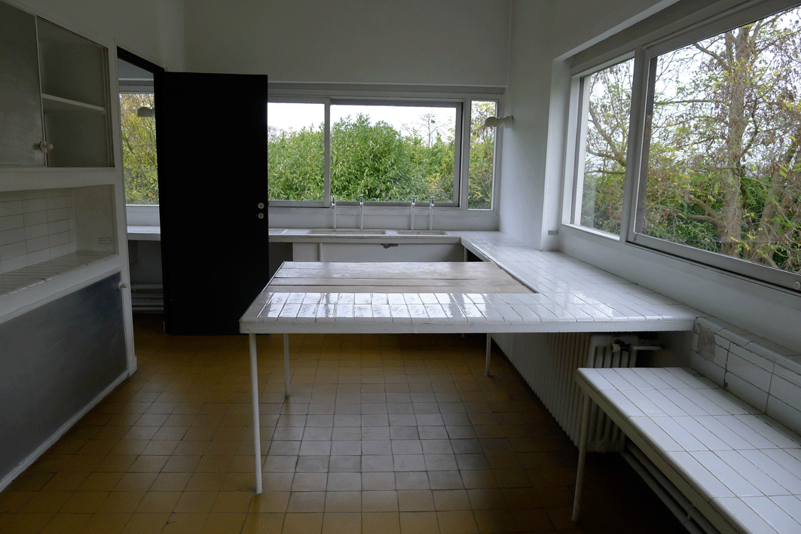of the living room are pale blue and pink in colour.

Figure 1.7 shows the living area in the Villa Savoye

Figure 1.6 shows the kitchen in the Villa Savoye

The small guest room is placed towards the northeast facade and includes a washing area. Below the ribbon windows is a sliding cupboard and shelves. The family that owned the Villa Savoye had a son known as Roger. Roger’s bedroom was placed directly below the hall from the guest room. His bedroom was also bigger than the guest room because it has bathroom equipped with a bathtub. However, the guest could also use the bathroom because it can be accessible from the hall. The master suite is an interesting space because it is “L” shaped and includes four areas which are the bathroom, bedroom, boudoir and dressing room. The floor and walls of the bathroom are 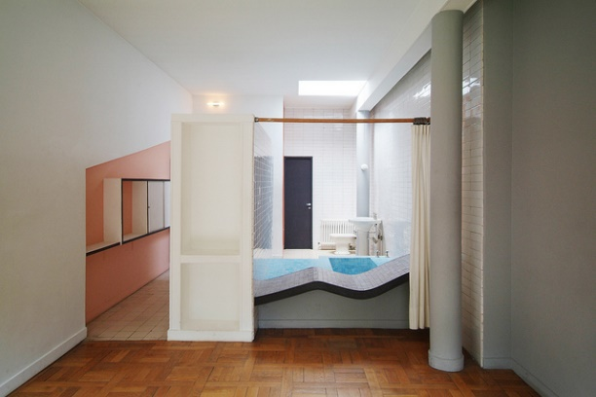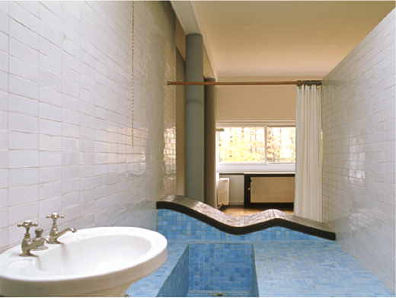covered in white tile but built-in tub is covered in blue tile.

Figure 1.9 shows the bathroom from the master bedroom

Figure 1.8 shows the bathroom in the Villa Savoye

The hanging garden, also known as the garden is placed towards the southwest facade. The reason for placing it towards the southwest façade is because it is open to the sky and it surrounded by a wall which has a ribbon window running the length of it. To decorate the area, there are planter boxes around the surroundings and large square paving stones are being used to cover the floor with narrow strips of grass between the paving stones. The roof of the building is equipped with a solarium and is alike to the hanging garden, although it is not completely surrounded by the wall. One more thing I think about the villa Savoye is that in its design and construction Le Corbusier made extensive use of hollow bricks.

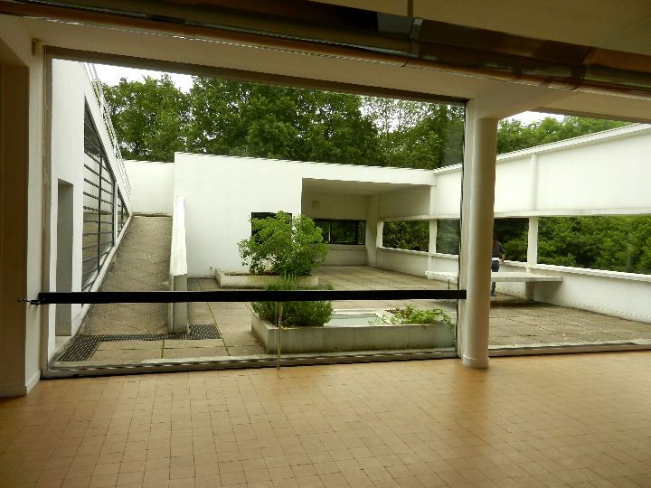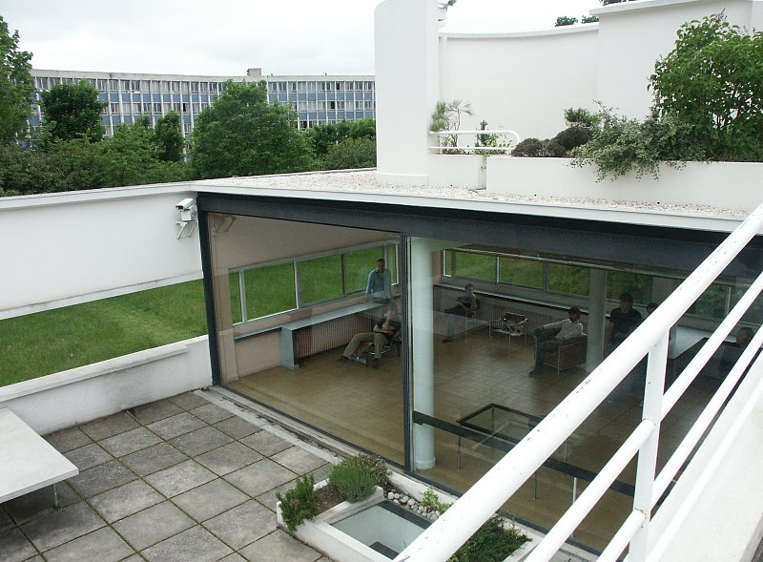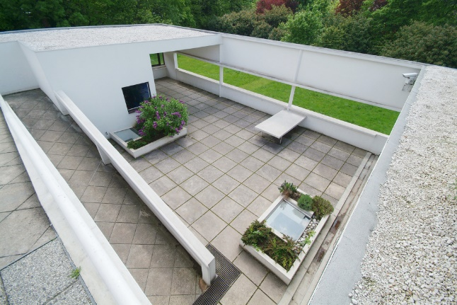

Figure 2.1 shows another view of the terrace garden

Figure 2.0 shows the entrance towards the terrace garden

Figure 2.2 shows another view of the terrace garden

After all the features about the Villa Savoye, lets take a look at the features towards the Fallingwater. Firstly, the Fallingwater is across a small bridge which spans Bear Run. The building is built using a large amount of stone, glass and reinforced concrete. Cantilevered portions of the house extend out over the creek. The driveway crosses the creek and goes around on the rear, or uphill side of the house where the entrance is beside a small square pool. Uphill from here and across the driveway is the addition containing the guest quarters and and garage. The entrance to the main house is into the coat room, from which a stairway rises to the main room on the main floor, entering the 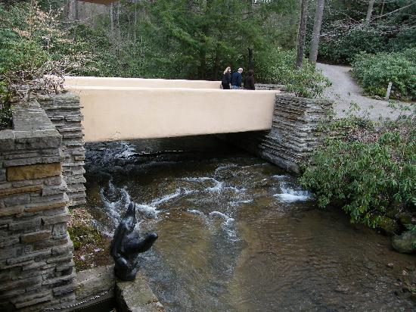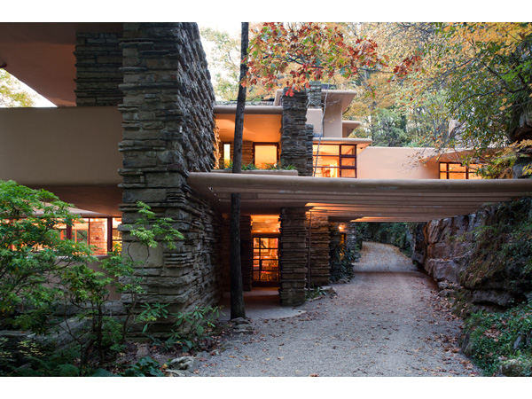dining area of the main room.

Figure 2.4 shows the entrance of the Fallingwater

Figure 2.3 shows the bridge of the Fallingwater which

spans the Bear Run

  The Fallingwater has a very interesting plan because it has an open floor plan, and the main room is one of the main focus in the building because it takes up the huge part of the first floor. The staff room and kitchen are placed towards the northwest corner of the house. Furthermore, towards the southwest corner of the house, an exposed terrace cantilevered is placed out over the Bear Run. The main first floor which is facing towards the eastern part is also an outdoor terrace cantilevered out over Bear Run. From this terrace stairs descend to the plunge pool below. It was here that the owner of the Fallingwater who is known as Kaufmanns, enjoyed spending time in the pool during

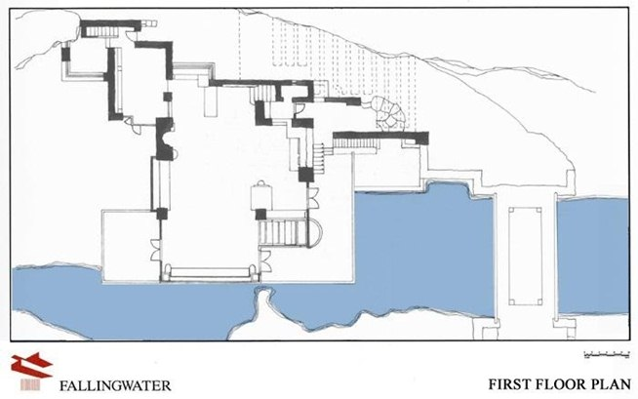summer. In addition, another set of stairs falls downwards to the run from inside the main room near its eastern end.

Figure 2.4 shows first floor plan of the Fallingwater

Figure 2.3 shows ground floor plan of the Fallingwater

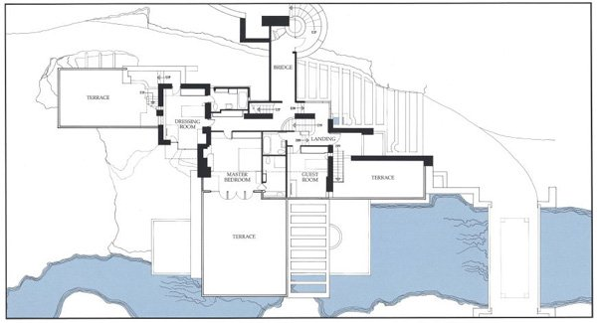

However facing towards the northwest part of the main room consist of the fireplace, with a native boulder extending through the floor, and forming the hearth. A large window facing the west is placed just south of the fireplace. Below this particular window and against the wall is a bench made out of wood comfy cushions on it. Furthermore, facing towards the south side of the room is a wide window looking out over the Bear Run. Moving towards the kitchen, it is equipped with a stove. Near the stove are big windows that has good views because it gives a view across the Bear Run. These windows which are made out of glass without any frame fits directly into a caulked groove in the stone work of the wall. Later on, the staff room was built to give the staff a better environment and to relax because the kitchen was not big enough for them. Also, the staff rooms were placed too far previous.

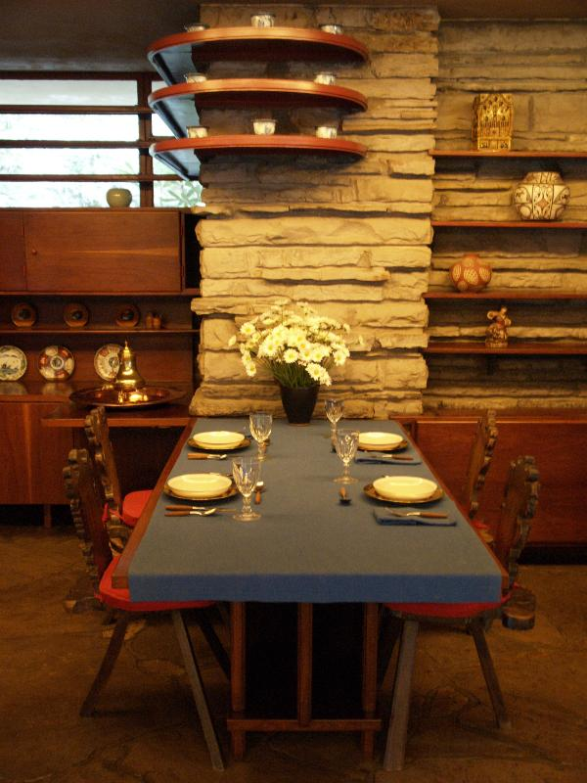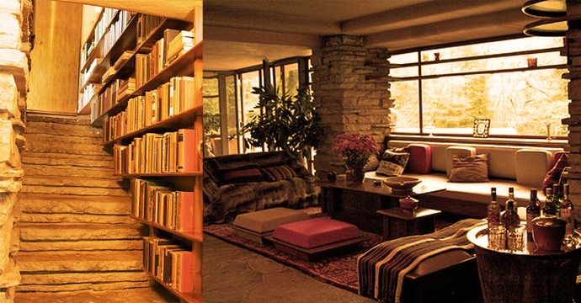

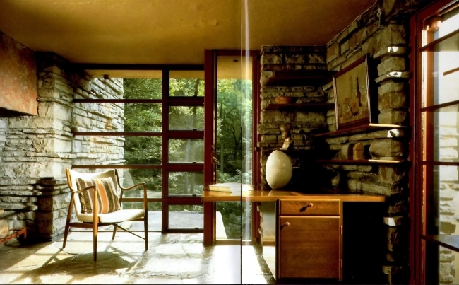

Figure 2.5 shows fireplace and the hearth of the Fallingwater

Figure 2.7 shows the dining area

Figure 2.6 shows classy windows

The operable windows have vertical frames whereas the fixed windows have horizontal frames throughout the house. Steel are being used for all of the window frames and is painted red in colour. Furthermore, the walls for the interior are either made out of glass or rough stacked stone. The second floor contains five spaces which are the guest room, the master suite and three large exposed terraces. Interestingly, there is also a bridge that spans the driveway and leads to the addition containing the garage and guest wing. The master suite consists of a dressing room, a master room, and a bathroom. The guest room has its own personal bathroom. Furthermore, the third floor consists of a large terrace with a large planter, as well as a bedroom and a study area. The addition has two floors. There is also a four car garage at the western end of the ground. The laundry room is placed towards the south of the. Also, facing the east of the laundry room is the guest apartment. Moving east one first comes to the living room, then the bathroom and then 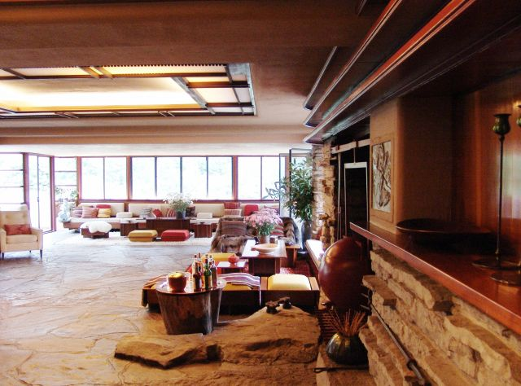the bedroom.

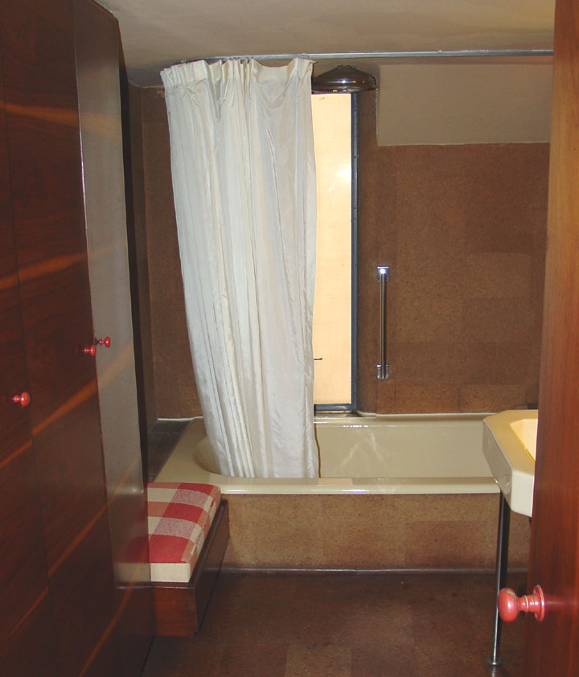

Figure 3.0 shows the bathroom of the Fallingwater

Figure 2.8 shows the living room of the Fallingwater

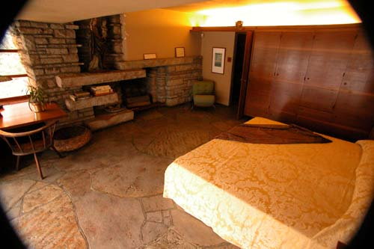

Figure 2.9 shows the master bedroom of the Fallingwater

To conclude, the features from the Villa Savoye and the Fallingwater are different in their own unique ways. For instance, the placement of the bedroom and living room differs based on their respective needs like the views. Some of the features are similar like the windows. Both the Villa Savoye and the Fallingwater have big ribbon windows to allow abundance of natural light into the house. Furthermore, the Villa Savoye acts as a machine for living whereas the Fallingwater just wants to integret and connects with its surrounding. Le Corbusier applied his five principles of architecture into the Villa Savoye but Frank Lloyd Wright focuses more on the horizontal and vertical elements on a building.

Reference

Villa Savoye and other buildings and projects, 1929-1930. (1984). New York: Garland ;.

Sbriglio, J. (1999). Le Corbusier: La villa Savoye = the villa Savoye (Bilingual original ed.). Basel: Birkhäuser Verlag.

Stevenson, N. (1997). Architecture. New York: DK Pub.

Frampton, K. (1992). Modern architecture: A critical history (3rd ed.). London: Thames and Hudson.

AD Classics: Villa Savoye / Le Corbusier. (2010, October 27). Retrieved June 2, 2015, from <http://www.archdaily.com/84524/ad-classics-villa-savoye-le-corbusier/>

Villa Savoye by Le Corbusier at GreatBuildings. (n.d.). Retrieved June 9, 2015, from <http://www.greatbuildings.com/buildings/villa_savoye.html>

Wright, F. (2011). Fallingwater. New York: Rizzoli :.

Wright, F. (1965). The work of Frank Lloyd Wright: The life-work of the American architect ; with contributions by Frank Llyod Wright. New York: Bramhall House.

Waggoner, L., & Wright, F. (1996). Fallingwater: Frank Lloyd Wright's romance with nature. Fallingwater, Pa.?: Fallingwater, Western Pennsylvania Conservancy ;.

Fallingwater pictures: Kitchen table and stove. (n.d.). Retrieved June 4, 2015, from <http://www.wright-house.com/frank-lloyd-wright/fallingwater-pictures/7-kitchen-table-stove.php>

Interior of Fallingwater, a Frank Lloyd Wright designed home in Pennsylvania  -  Travel Photos by Galen R Frysinger, Sheboygan, Wisconsin. (n.d.). Retrieved June 9, 2015, from <http://www.galenfrysinger.com/fallingwater_interior.htm>

Image Reference

<https://www.google.com/url?sa=i&rct=j&q=&esrc=s&source=images&cd=&cad=rja&uact=8&ved=0CAcQjRw&url=http%3A%2F%2Fwww.architectural-review.com%2Fessays%2Fthe-big-rethink-part-2-farewell-to-modernism-and-modernity-too%2F8625733.article&ei=Uhd3VYfQDYT98AWX6oKYCg&bvm=bv.95039771,d.dGc&psig=AFQjCNHwxdEr1W6mM0nkh8kIiYVm8Cerlg&ust=1433954508955929>

<https://www.google.com/imgres?imgurl=https%3A%2F%2Fc2.staticflickr.com%2F6%2F5162%2F5292854611_0fb73dc35c_z.jpg&imgrefurl=http%3A%2F%2Fadelagrusova.blogspot.com%2F2015%2F03%2Fwhen-innovative-idea-meets-reality.html&docid=7hVZeqOrO64uaM&tbnid=ESdizWUR7JT7bM&w=640&h=438&ei=Uhd3VdbMF8j98AXiyIDQAg&ved=0CAQQxiAwAg&iact=c>

<https://www.google.com/url?sa=i&rct=j&q=&esrc=s&source=images&cd=&cad=rja&uact=8&ved=0CAcQjRw&url=https%3A%2F%2Fwww.bluffton.edu%2F~sullivanm%2Ffrance%2Fpoissy%2Fsavoye%2Fcorbu6.html&ei=hhd3VZmoLczW8gWi8oHoDA&bvm=bv.95039771,d.dGc&psig=AFQjCNHwxdEr1W6mM0nkh8kIiYVm8Cerlg&ust=1433954508955929>

<https://www.google.com/url?sa=i&rct=j&q=&esrc=s&source=images&cd=&cad=rja&uact=8&ved=0CAcQjRw&url=https%3A%2F%2Fwww.bluffton.edu%2F~sullivanm%2Ffrance%2Fpoissy%2Fsavoye%2Fcorbu2.html&ei=qxd3VbfjDsPh8AWAlYC4AQ&bvm=bv.95039771,d.dGc&psig=AFQjCNHwxdEr1W6mM0nkh8kIiYVm8Cerlg&ust=1433954508955929>

<https://www.google.com/url?sa=i&rct=j&q=&esrc=s&source=images&cd=&cad=rja&uact=8&ved=0CAcQjRw&url=http%3A%2F%2Fmisfitsarchitecture.com%2Ftag%2Fvilla-savoye-structure%2F&ei=uRd3VavvO8rr8AWbroHwCw&bvm=bv.95039771,d.dGc&psig=AFQjCNHwxdEr1W6mM0nkh8kIiYVm8Cerlg&ust=1433954508955929>

<https://www.google.com/url?sa=i&rct=j&q=&esrc=s&source=images&cd=&cad=rja&uact=8&ved=0CAcQjRw&url=http%3A%2F%2Fwww.fallingwater.org%2F8%2Fpreparing-for-your-visit-to-fallingwater&ei=0hd3VdCYDY_q8AWIiYGQDA&bvm=bv.95039771,d.dGc&psig=AFQjCNEWQO41eXFaSXToyoE1Z813aRQLjg&ust=1433954637606717>

<https://www.google.com/url?sa=i&rct=j&q=&esrc=s&source=images&cd=&cad=rja&uact=8&ved=0CAcQjRw&url=http%3A%2F%2Fimgkid.com%2Ffallingwater-kitchen.shtml&ei=3xd3VfPlLMro8AXW3ICQAg&bvm=bv.95039771,d.dGc&psig=AFQjCNEWQO41eXFaSXToyoE1Z813aRQLjg&ust=1433954637606717>

<https://www.google.com/url?sa=i&rct=j&q=&esrc=s&source=images&cd=&cad=rja&uact=8&ved=0CAcQjRw&url=http%3A%2F%2Fcommons.wikimedia.org%2Fwiki%2FFile%3AFrank_Lloyd_Wright_-_Fallingwater_interior_7.JPG&ei=6xd3VcH3EsLg8AWw14NI&bvm=bv.95039771,d.dGc&psig=AFQjCNETyzXGpp5BYHuIL9reBCI_1eBF0Q&ust=1433954665583470>

<https://www.google.com/url?sa=i&rct=j&q=&esrc=s&source=images&cd=&cad=rja&uact=8&ved=0CAcQjRw&url=http%3A%2F%2Fwww.designrulz.com%2Farchitecture%2F2012%2F10%2Ffallingwater-house-by-frank-lloyd-wright%2F&ei=9hd3VbeuNIy48gX6vIPwBw&bvm=bv.95039771,d.dGc&psig=AFQjCNETyzXGpp5BYHuIL9reBCI_1eBF0Q&ust=1433954665583470>

<https://www.google.com/url?sa=i&rct=j&q=&esrc=s&source=images&cd=&cad=rja&uact=8&ved=0CAcQjRw&url=http%3A%2F%2Fwww.tripadvisor.com%2FLocationPhotoDirectLink-g53192-d116601-i17796161-Fallingwater-Mill_Run_Pennsylvania.html&ei=FBh3VZqeGs2F8gXRyIPoCw&bvm=bv.95039771,d.dGc&psig=AFQjCNFJueb_o-YehTuNLh-XVY8hwbqw8Q&ust=1433954704820581>

<https://www.google.com/url?sa=i&rct=j&q=&esrc=s&source=images&cd=&cad=rja&uact=8&ved=&url=http%3A%2F%2Fwideworldofgeometry.pbworks.com%2Fw%2Fpage%2F14141625%2FSample%2520Architectural%2520New%2520Building%2520Project&ei=EBh3VaGGHMLm8AXpz4DoCg&bvm=bv.95039771,d.dGc&psig=AFQjCNFJueb_o-YehTuNLh-XVY8hwbqw8Q&ust=1433954704820581>

<https://www.google.com/url?sa=i&rct=j&q=&esrc=s&source=images&cd=&cad=rja&uact=8&ved=0CAcQjRw&url=http%3A%2F%2Fwww.galenfrysinger.com%2Ffallingwater_interior.htm&ei=SRh3VYjyFsfr8AX4voBo&bvm=bv.95039771,d.dGc&psig=AFQjCNECqmOTvRfCPOKj_oL6WylsTiZG3Q&ust=1433954756842280>

<https://www.google.com/url?sa=i&rct=j&q=&esrc=s&source=images&cd=&cad=rja&uact=8&ved=0CAcQjRw&url=http%3A%2F%2Fwww.giesendesign.com%2Fdesign%2F890x563%2Farchitecture-frank-ideas%2Farchitecture-frank-lloyd-wright-fallingwater-interior-wooden-furniture-and-glazed-windows-discover-the-fallingwater-in-pennsylvania-designed-by-frank-lloyd-wright-22206.html&ei=YRh3VbbMM9Hj8AXwioPYCA&bvm=bv.95039771,d.dGc&psig=AFQjCNECqmOTvRfCPOKj_oL6WylsTiZG3Q&ust=1433954756842280>

<https://www.google.com/url?sa=i&rct=j&q=&esrc=s&source=images&cd=&cad=rja&uact=8&ved=0CAcQjRw&url=http%3A%2F%2Fpixshark.com%2Ffallingwater-interior-bedrooms.htm&ei=eBh3VY-uBYj-8QWXhICoDw&bvm=bv.95039771,d.dGc&psig=AFQjCNECqmOTvRfCPOKj_oL6WylsTiZG3Q&ust=1433954756842280>

<https://www.google.com/url?sa=i&rct=j&q=&esrc=s&source=images&cd=&cad=rja&uact=8&ved=0CAcQjRw&url=https%3A%2F%2Fsites.google.com%2Fsite%2Fartwithmrflash%2Ffranklloydwright%27s%2522fallingwater%2522&ei=lRh3VZrOJdOk8AW03oCwCw&bvm=bv.95039771,d.dGc&psig=AFQjCNGIdExCVJcTicggwREmfkBCskeGXQ&ust=1433954834126500>

<https://www.google.com/url?sa=i&rct=j&q=&esrc=s&source=images&cd=&cad=rja&uact=8&ved=0CAcQjRw&url=http%3A%2F%2Fwww.designrulz.com%2Farchitecture%2F2012%2F10%2Ffallingwater-house-by-frank-lloyd-wright%2F&ei=pRh3VefvDdS78gXxpoAw&bvm=bv.95039771,d.dGc&psig=AFQjCNGIdExCVJcTicggwREmfkBCskeGXQ&ust=1433954834126500>